**Steps to Insert Products using Postman Tool**

**Step 1:**

Create a new Request in the Postman Tool .

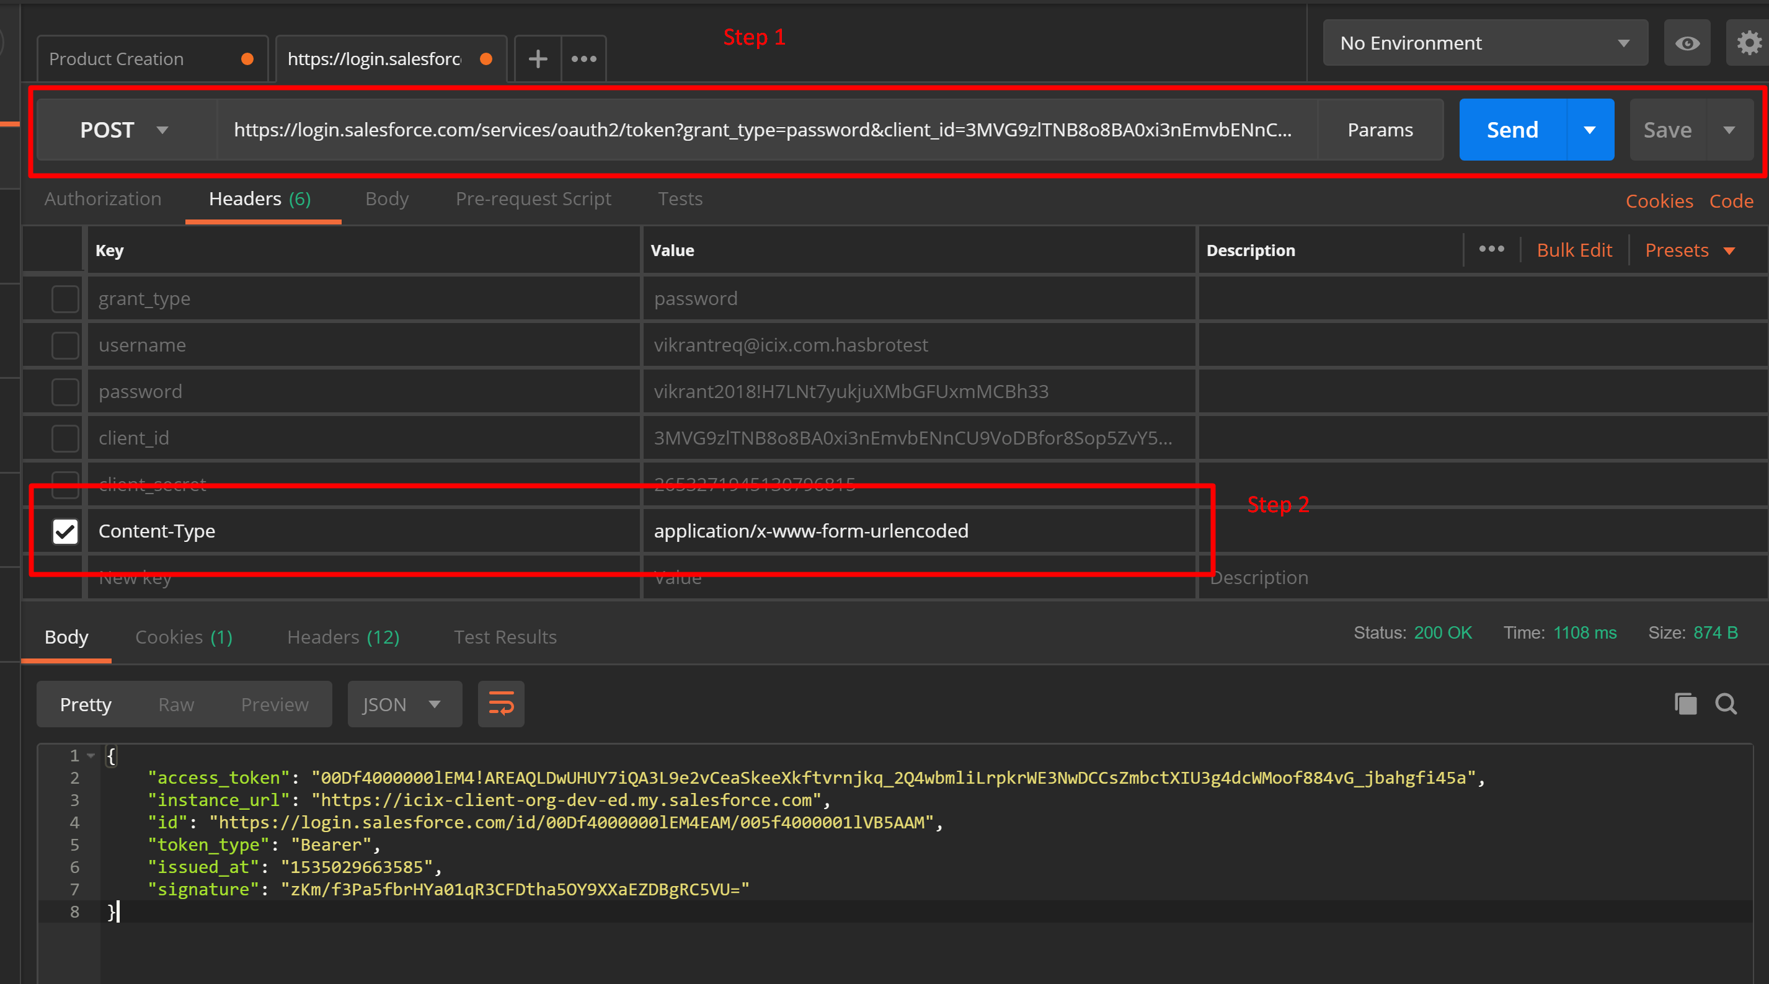

Method : Post

Content-Type : application/x-www-form-urlencoded

**End Point :** <https://login.salesforce.com/services/oauth2/token?grant_type=password&client_id=3MVG9zlTNB8o8BA0xi3nEmvbENnCU9VoDBfor8Sop5ZvY5mHuFOgLRZ8l4z9kWASUn7PzI2MUYcIgo8JTa9VB&client_secret=2653271945130796815&username=vikrantreq@icix.com.hasbrotest&password=vikrant2018!H7LNt7yukjuXMbGFUxmMCBh33>

**Click on the Send Button and observe the Response in the body.**

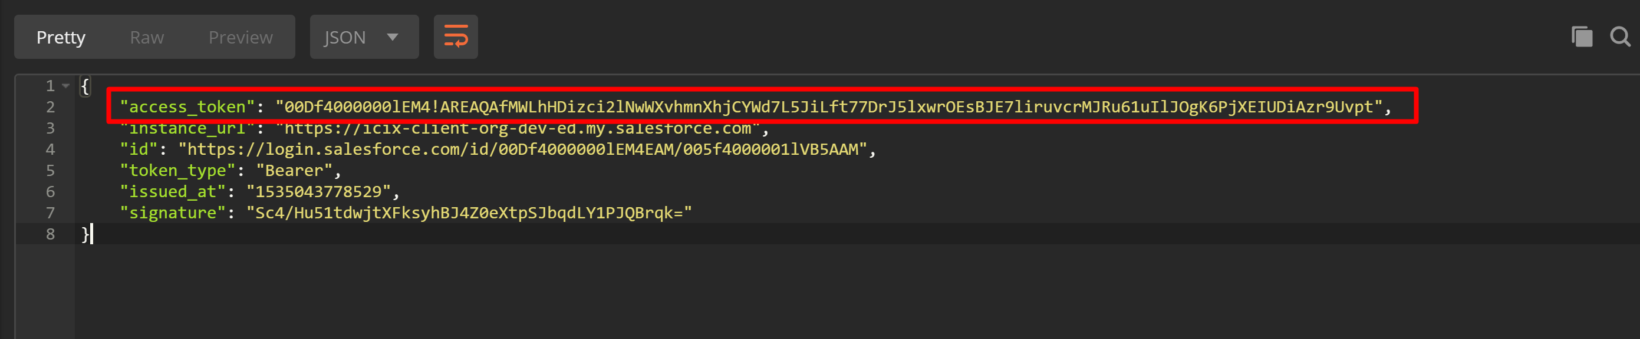

**Copy the access_token highlighted and Save it .**

**Step 2:**

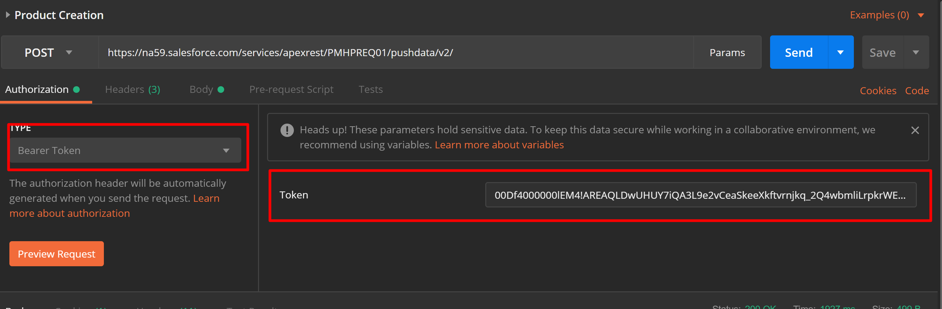

**Select Bearer Token in the Authorization Tab and Copy the Token generated in First Step in the token Field.**

**End Point :** <https://na59.salesforce.com/services/apexrest/PMHPREQ01/pushdata/v2/>

**Method**: POST

**Content-Type : application/json**

**Accept : application/json**

**Add the Headers in the Headers Tabs.**

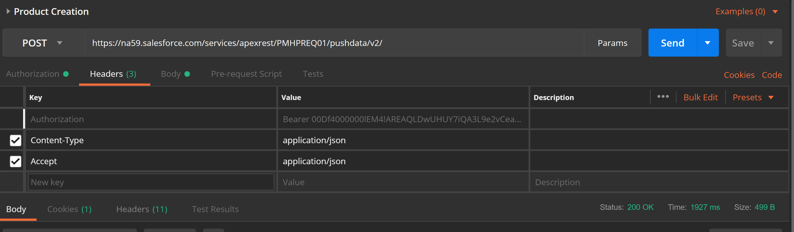

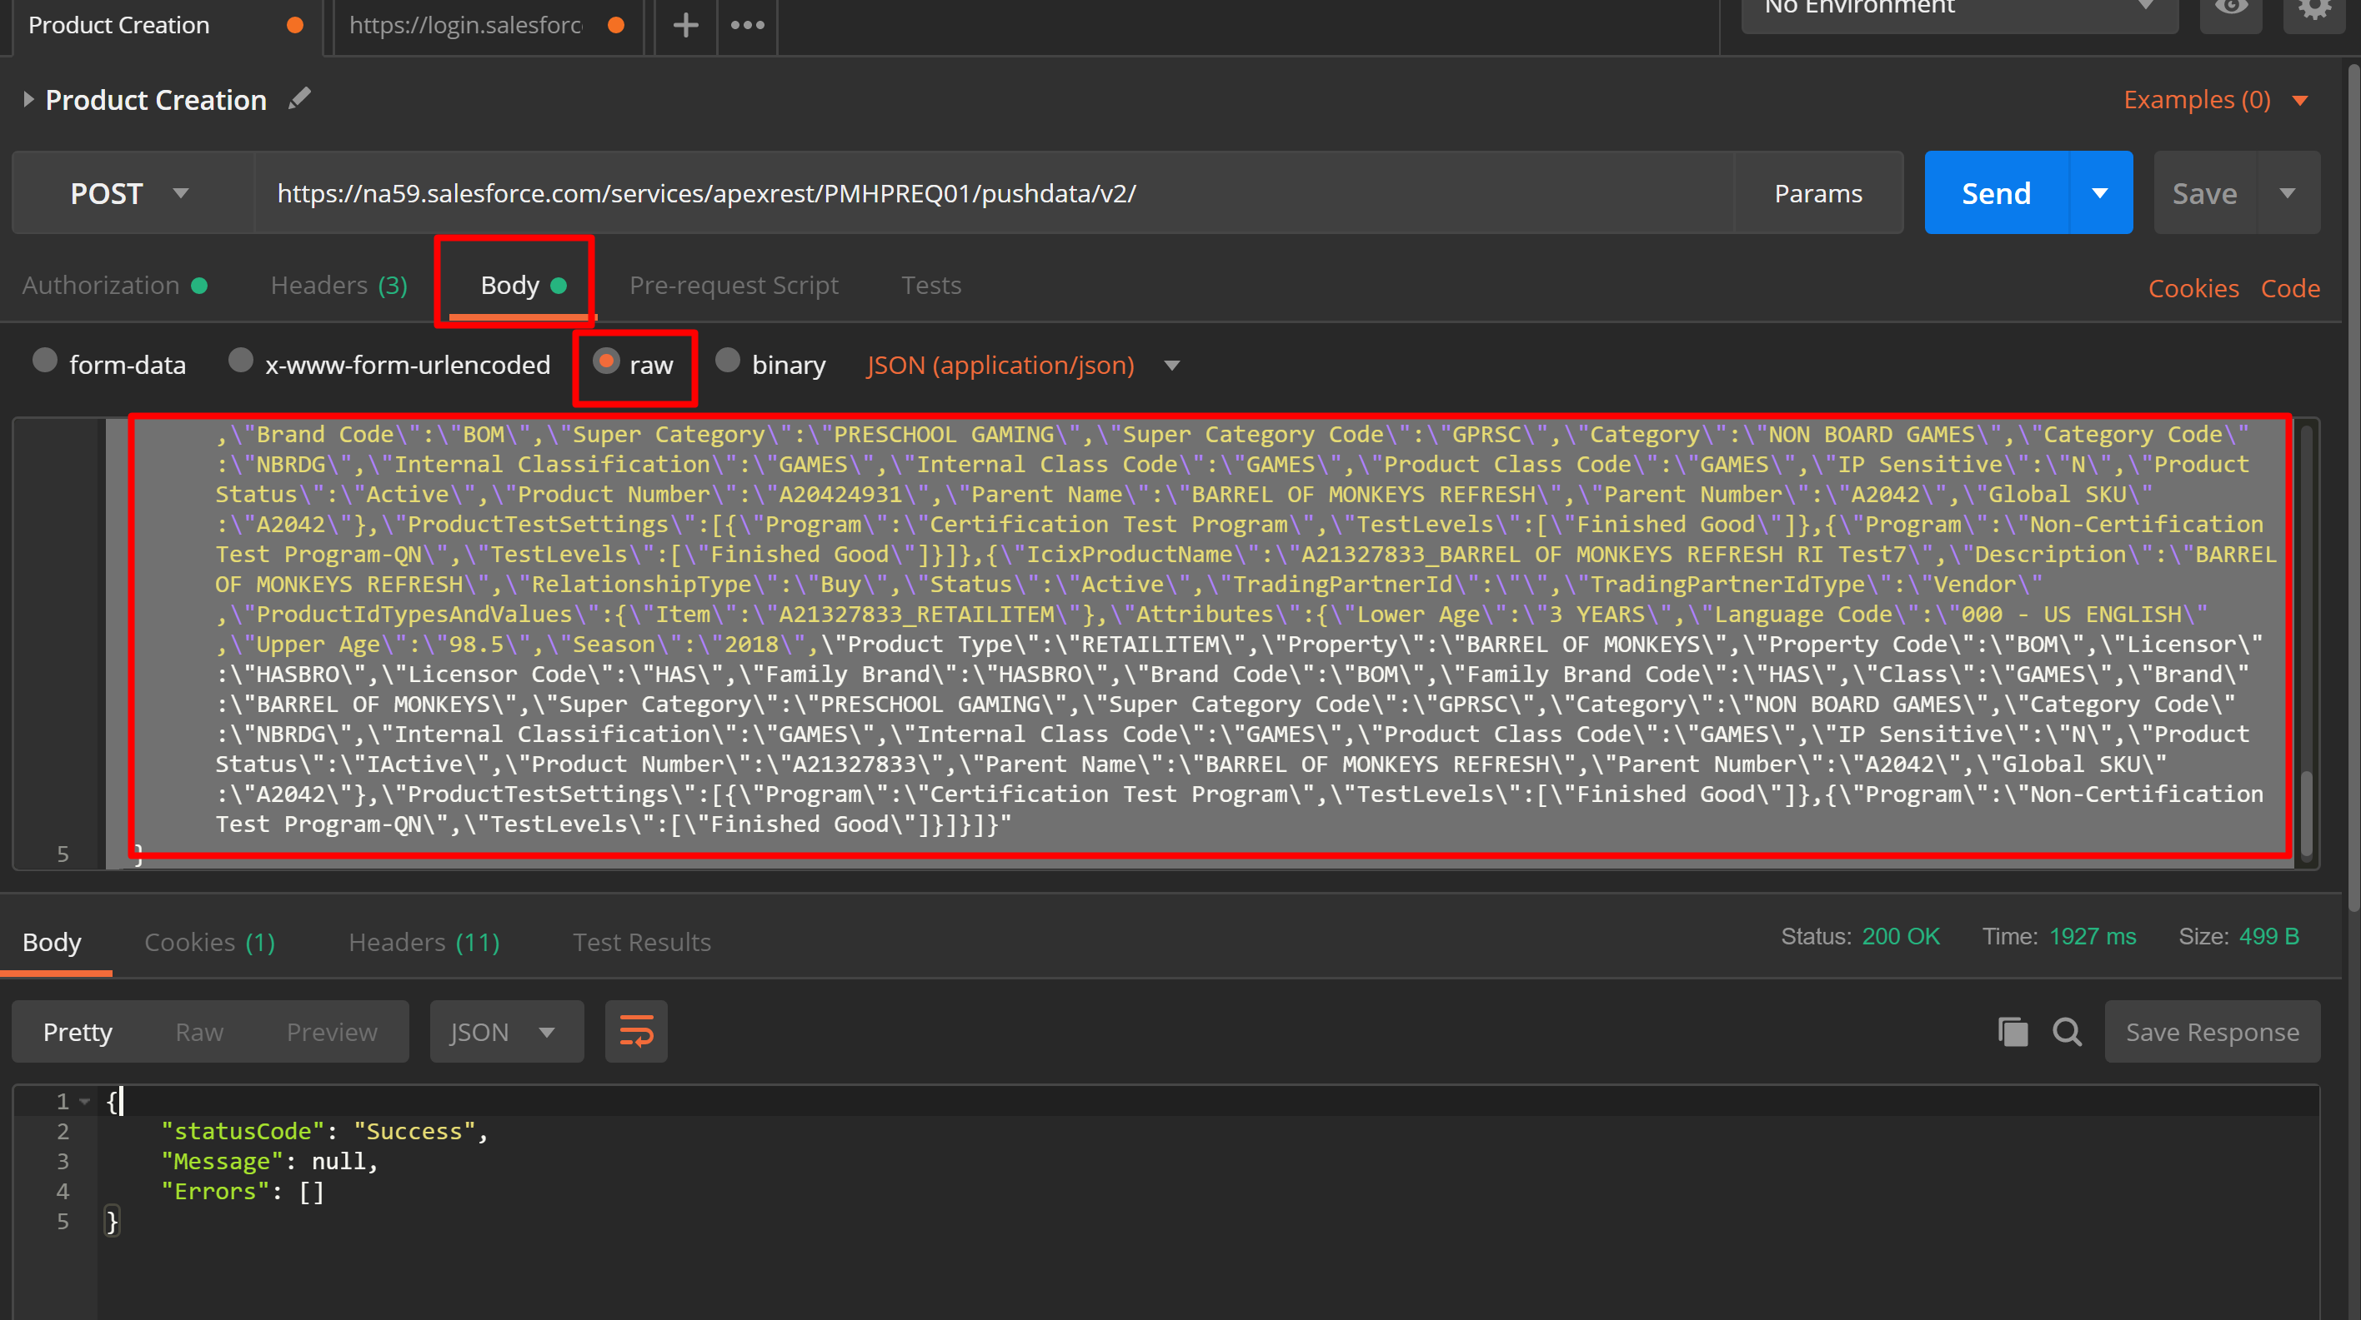

Click on the Body Tab and select the raw Checkbox and add the Json in the highlighted box.

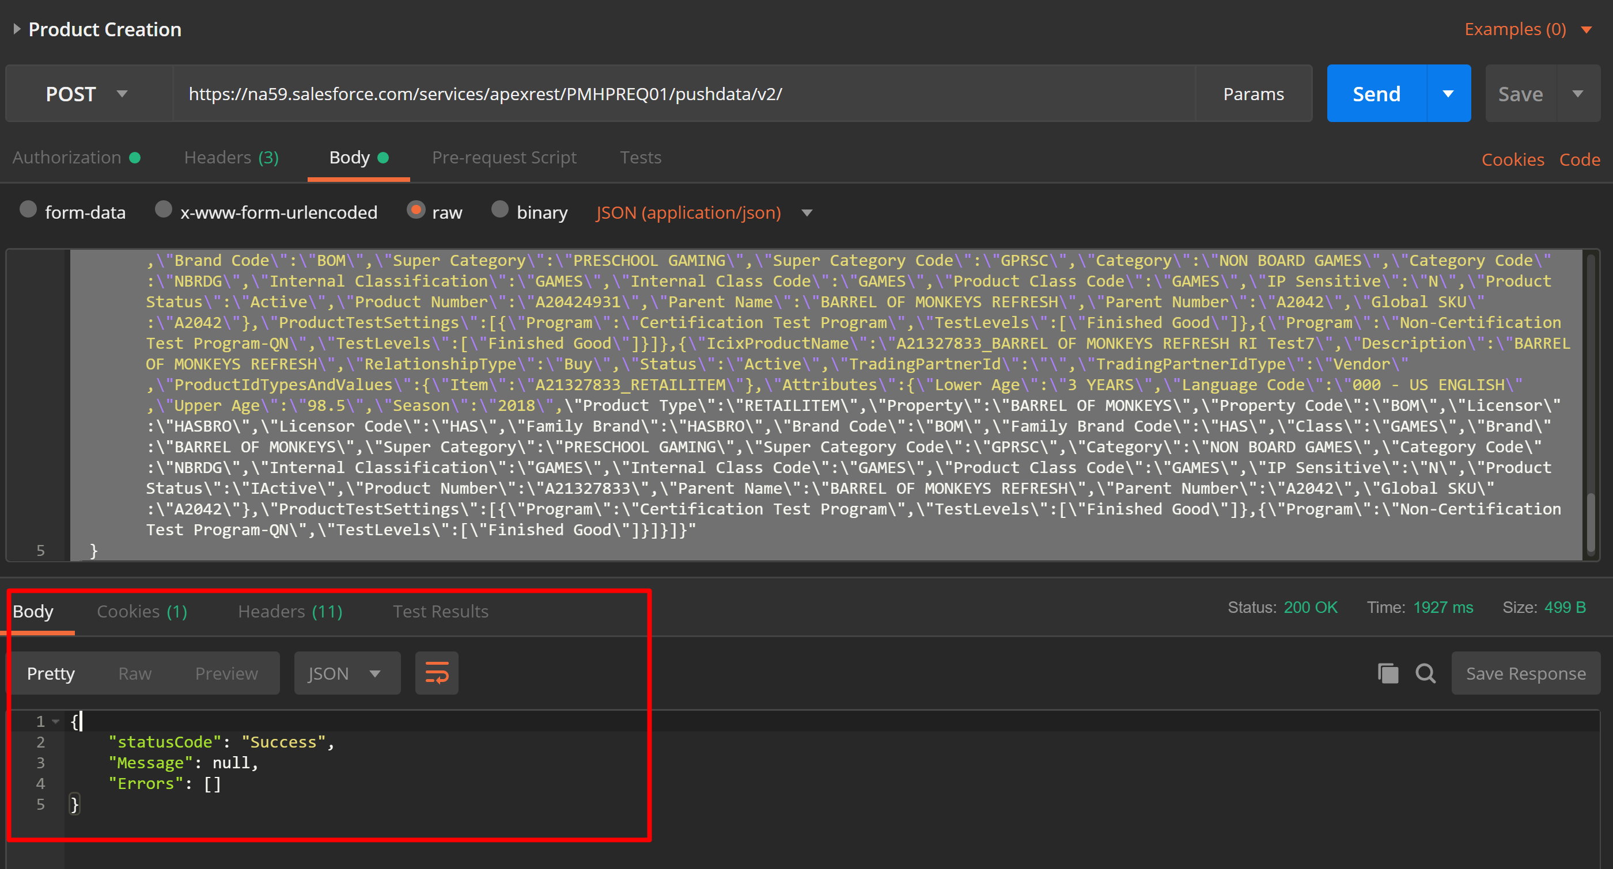

Click on the Send Button and check the Results in the Salesforce and Response in the Tool(Highlighted below)

**Sample Json :**

{

"settings": {

"Command": "AddProducts",

"ApiParameters": "{\"CompanyICIXID\":\"301053\",\"Products\":[{\"IcixProductName\":\"A20421111_BARREL OF MONKEYS REFRESH RI Test1\",\"Description\":\"BARREL OF MONKEYS REFRESH\",\"RelationshipType\":\"Buy\",\"Status\":\"Active\",\"TradingPartnerId\":\"\",\"TradingPartnerIdType\":\"Vendor\",\"ProductIdTypesAndValues\":{\"Item\":\"A20421111_RETAILITEM\"},\"Attributes\":{\"Lower Age\":\"3 YEARS\",\"Language Code\":\"000 - US ENGLISH\",\"Upper Age\":\"98.5\",\"Season\":\"2018\",\"Product Type\":\"RETAILITEM\",\"Property\":\"BARREL OF MONKEYS\",\"Property Code\":\"BOM\",\"Licensor\":\"HASBRO\",\"Licensor Code\":\"HAS\",\"Family Brand\":\"HASBRO\",\"Family Brand Code\":\"HAS\",\"Class\":\"GAMES\",\"Brand\":\"BARREL OF MONKEYS\",\"Brand Code\":\"BOM\",\"Super Category\":\"PRESCHOOL GAMING\",\"Super Category Code\":\"GPRSC\",\"Category\":\"NON BOARD GAMES\",\"Category Code\":\"NBRDG\",\"Internal Classification\":\"GAMES\",\"Internal Class Code\":\"GAMES\",\"Product Class Code\":\"GAMES\",\"IP Sensitive\":\"N\",\"Product Status\":\"Active\",\"Product Number\":\"A20421111\",\"Parent Name\":\"BARREL OF MONKEYS REFRESH\",\"Parent Number\":\"A2042\",\"Global SKU\":\"A2042\"},\"ProductTestSettings\":[{\"Program\":\"Certification Test Program\",\"TestLevels\":[\"Finished Good\"]},{\"Program\":\"Non-Certification Test Program-QN\",\"TestLevels\":[\"Finished Good\"]}]},{\"IcixProductName\":\"A20412222_BARREL OF MONKEYS REFRESH RI Test2\",\"Description\":\"BARREL OF MONKEYS REFRESH\",\"RelationshipType\":\"Buy\",\"Status\":\"Active\",\"TradingPartnerId\":\"\",\"TradingPartnerIdType\":\"Vendor\",\"ProductIdTypesAndValues\":{\"Item\":\"A20422222_RETAILITEM\"},\"Attributes\":{\"Lower Age\":\"3 YEARS\",\"Language Code\":\"000 - US ENGLISH\",\"Upper Age\":\"98.5\",\"Season\":\"2018\",\"Product Type\":\"RETAILITEM\",\"Property\":\"BARREL OF MONKEYS\",\"Property Code\":\"BOM\",\"Licensor\":\"HASBRO\",\"Licensor Code\":\"HAS\",\"Family Brand\":\"HASBRO\",\"Brand Code\":\"BOM\",\"Family Brand Code\":\"HAS\",\"Class\":\"GAMES\",\"Brand\":\"BARREL OF MONKEYS\",\"Super Category\":\"PRESCHOOL GAMING\",\"Super Category Code\":\"GPRSC\",\"Category\":\"NON BOARD GAMES\",\"Category Code\":\"NBRDG\",\"Internal Classification\":\"GAMES\",\"Internal Class Code\":\"GAMES\",\"Product Class Code\":\"GAMES\",\"IP Sensitive\":\"N\",\"Product Status\":\"IActive\",\"Product Number\":\"A20422222\",\"Parent Name\":\"BARREL OF MONKEYS REFRESH\",\"Parent Number\":\"A2042\",\"Global SKU\":\"A2042\"},\"ProductTestSettings\":[{\"Program\":\"Certification Test Program\",\"TestLevels\":[\"Finished Good\"]},{\"Program\":\"Non-Certification Test Program-QN\",\"TestLevels\":[\"Finished Good\"]}]},{\"IcixProductName\":\"A20423321_BARREL OF MONKEYS REFRESH RI Test3\",\"Description\":\"BARREL OF MONKEYS REFRESH\",\"RelationshipType\":\"Buy\",\"Status\":\"Active\",\"TradingPartnerId\":\"\",\"TradingPartnerIdType\":\"Vendor\",\"ProductIdTypesAndValues\":{\"Item\":\"A20423321_RETAILITEM\"},\"Attributes\":{\"Lower Age\":\"3 YEARS\",\"Language Code\":\"000 - US ENGLISH\",\"Upper Age\":\"98.5\",\"Season\":\"2018\",\"Product Type\":\"RETAILITEM\",\"Property\":\"BARREL OF MONKEYS\",\"Property Code\":\"BOM\",\"Licensor\":\"HASBRO\",\"Licensor Code\":\"HAS\",\"Family Brand\":\"HASBRO\",\"Family Brand Code\":\"HAS\",\"Class\":\"GAMES\",\"Brand\":\"BARREL OF MONKEYS\",\"Brand Code\":\"BOM\",\"Super Category\":\"PRESCHOOL GAMING\",\"Super Category Code\":\"GPRSC\",\"Category\":\"NON BOARD GAMES\",\"Category Code\":\"NBRDG\",\"Internal Classification\":\"GAMES\",\"Internal Class Code\":\"GAMES\",\"Product Class Code\":\"GAMES\",\"IP Sensitive\":\"N\",\"Product Status\":\"Active\",\"Product Number\":\"A20423321\",\"Parent Name\":\"BARREL OF MONKEYS REFRESH\",\"Parent Number\":\"A2042\",\"Global SKU\":\"A2042\"},\"ProductTestSettings\":[{\"Program\":\"Certification Test Program\",\"TestLevels\":[\"Finished Good\"]},{\"Program\":\"Non-Certification Test Program-QN\",\"TestLevels\":[\"Finished Good\"]}]},{\"IcixProductName\":\"A20419732_BARREL OF MONKEYS REFRESH RI Test4\",\"Description\":\"BARREL OF MONKEYS REFRESH\",\"RelationshipType\":\"Buy\",\"Status\":\"Active\",\"TradingPartnerId\":\"\",\"TradingPartnerIdType\":\"Vendor\",\"ProductIdTypesAndValues\":{\"Item\":\"A20419732_RETAILITEM\"},\"Attributes\":{\"Lower Age\":\"3 YEARS\",\"Language Code\":\"000 - US ENGLISH\",\"Upper Age\":\"98.5\",\"Season\":\"2018\",\"Product Type\":\"RETAILITEM\",\"Property\":\"BARREL OF MONKEYS\",\"Property Code\":\"BOM\",\"Licensor\":\"HASBRO\",\"Licensor Code\":\"HAS\",\"Family Brand\":\"HASBRO\",\"Brand Code\":\"BOM\",\"Family Brand Code\":\"HAS\",\"Class\":\"GAMES\",\"Brand\":\"BARREL OF MONKEYS\",\"Super Category\":\"PRESCHOOL GAMING\",\"Super Category Code\":\"GPRSC\",\"Category\":\"NON BOARD GAMES\",\"Category Code\":\"NBRDG\",\"Internal Classification\":\"GAMES\",\"Internal Class Code\":\"GAMES\",\"Product Class Code\":\"GAMES\",\"IP Sensitive\":\"N\",\"Product Status\":\"IActive\",\"Product Number\":\"A20419732\",\"Parent Name\":\"BARREL OF MONKEYS REFRESH\",\"Parent Number\":\"A2042\",\"Global SKU\":\"A2042\"},\"ProductTestSettings\":[{\"Program\":\"Certification Test Program\",\"TestLevels\":[\"Finished Good\"]},{\"Program\":\"Non-Certification Test Program-QN\",\"TestLevels\":[\"Finished Good\"]}]},{\"IcixProductName\":\"A21329932_BARREL OF MONKEYS REFRESH RI Test5\",\"Description\":\"BARREL OF MONKEYS REFRESH\",\"RelationshipType\":\"Buy\",\"Status\":\"Active\",\"TradingPartnerId\":\"\",\"TradingPartnerIdType\":\"Vendor\",\"ProductIdTypesAndValues\":{\"Item\":\"A21329932_RETAILITEM\"},\"Attributes\":{\"Lower Age\":\"3 YEARS\",\"Language Code\":\"000 - US ENGLISH\",\"Upper Age\":\"98.5\",\"Season\":\"2018\",\"Product Type\":\"RETAILITEM\",\"Property\":\"BARREL OF MONKEYS\",\"Property Code\":\"BOM\",\"Licensor\":\"HASBRO\",\"Licensor Code\":\"HAS\",\"Family Brand\":\"HASBRO\",\"Brand Code\":\"BOM\",\"Family Brand Code\":\"HAS\",\"Class\":\"GAMES\",\"Brand\":\"BARREL OF MONKEYS\",\"Super Category\":\"PRESCHOOL GAMING\",\"Super Category Code\":\"GPRSC\",\"Category\":\"NON BOARD GAMES\",\"Category Code\":\"NBRDG\",\"Internal Classification\":\"GAMES\",\"Internal Class Code\":\"GAMES\",\"Product Class Code\":\"GAMES\",\"IP Sensitive\":\"N\",\"Product Status\":\"IActive\",\"Product Number\":\"A21329932\",\"Parent Name\":\"BARREL OF MONKEYS REFRESH\",\"Parent Number\":\"A2042\",\"Global SKU\":\"A2042\"},\"ProductTestSettings\":[{\"Program\":\"Certification Test Program\",\"TestLevels\":[\"Finished Good\"]},{\"Program\":\"Non-Certification Test Program-QN\",\"TestLevels\":[\"Finished Good\"]}]},{\"IcixProductName\":\"A20424931_BARREL OF MONKEYS REFRESH RI Test6\",\"Description\":\"BARREL OF MONKEYS REFRESH\",\"RelationshipType\":\"Buy\",\"Status\":\"Active\",\"TradingPartnerId\":\"\",\"TradingPartnerIdType\":\"Vendor\",\"ProductIdTypesAndValues\":{\"Item\":\"A20424931_RETAILITEM\"},\"Attributes\":{\"Lower Age\":\"3 YEARS\",\"Language Code\":\"000 - US ENGLISH\",\"Upper Age\":\"98.5\",\"Season\":\"2018\",\"Product Type\":\"RETAILITEM\",\"Property\":\"BARREL OF MONKEYS\",\"Property Code\":\"BOM\",\"Licensor\":\"HASBRO\",\"Licensor Code\":\"HAS\",\"Family Brand\":\"HASBRO\",\"Family Brand Code\":\"HAS\",\"Class\":\"GAMES\",\"Brand\":\"BARREL OF MONKEYS\",\"Brand Code\":\"BOM\",\"Super Category\":\"PRESCHOOL GAMING\",\"Super Category Code\":\"GPRSC\",\"Category\":\"NON BOARD GAMES\",\"Category Code\":\"NBRDG\",\"Internal Classification\":\"GAMES\",\"Internal Class Code\":\"GAMES\",\"Product Class Code\":\"GAMES\",\"IP Sensitive\":\"N\",\"Product Status\":\"Active\",\"Product Number\":\"A20424931\",\"Parent Name\":\"BARREL OF MONKEYS REFRESH\",\"Parent Number\":\"A2042\",\"Global SKU\":\"A2042\"},\"ProductTestSettings\":[{\"Program\":\"Certification Test Program\",\"TestLevels\":[\"Finished Good\"]},{\"Program\":\"Non-Certification Test Program-QN\",\"TestLevels\":[\"Finished Good\"]}]},{\"IcixProductName\":\"A21327833_BARREL OF MONKEYS REFRESH RI Test7\",\"Description\":\"BARREL OF MONKEYS REFRESH\",\"RelationshipType\":\"Buy\",\"Status\":\"Active\",\"TradingPartnerId\":\"\",\"TradingPartnerIdType\":\"Vendor\",\"ProductIdTypesAndValues\":{\"Item\":\"A21327833_RETAILITEM\"},\"Attributes\":{\"Lower Age\":\"3 YEARS\",\"Language Code\":\"000 - US ENGLISH\",\"Upper Age\":\"98.5\",\"Season\":\"2018\",\"Product Type\":\"RETAILITEM\",\"Property\":\"BARREL OF MONKEYS\",\"Property Code\":\"BOM\",\"Licensor\":\"HASBRO\",\"Licensor Code\":\"HAS\",\"Family Brand\":\"HASBRO\",\"Brand Code\":\"BOM\",\"Family Brand Code\":\"HAS\",\"Class\":\"GAMES\",\"Brand\":\"BARREL OF MONKEYS\",\"Super Category\":\"PRESCHOOL GAMING\",\"Super Category Code\":\"GPRSC\",\"Category\":\"NON BOARD GAMES\",\"Category Code\":\"NBRDG\",\"Internal Classification\":\"GAMES\",\"Internal Class Code\":\"GAMES\",\"Product Class Code\":\"GAMES\",\"IP Sensitive\":\"N\",\"Product Status\":\"IActive\",\"Product Number\":\"A21327833\",\"Parent Name\":\"BARREL OF MONKEYS REFRESH\",\"Parent Number\":\"A2042\",\"Global SKU\":\"A2042\"},\"ProductTestSettings\":[{\"Program\":\"Certification Test Program\",\"TestLevels\":[\"Finished Good\"]},{\"Program\":\"Non-Certification Test Program-QN\",\"TestLevels\":[\"Finished Good\"]}]}]}"

}

}

{ "settings":

{ "Command": "AddProducts",

"ApiParameters": " " ===>JSON String of the Files.

} }

Use the website to Convert JSON to String and add the generated Json string in the ApiParameters.

[**http://tools.knowledgewalls.com/jsontostring**](http://tools.knowledgewalls.com/jsontostring)

https://test.salesforce.com/services/oauth2/token?grant_type=password&client_id=3MVG973QtA4.tpvl6wjb32RBqgEARQVt82xt3ultACcZ1dSbT9tGCpyCE8FjfkSrSDMdBqjKPup4x8.XDGaUq&client_secret=E6C8ED618E09B61106CFA21FCAE8D03ABF6EF35B57CA2AA90BBEC00E20243490&username= sandeep.api@icix.com&password= Hasbro@123d1I7811NXVKIu3xdGx77BYpj

**Sample ICIX POST URL:**

https://test.salesforce.com/services/oauth2/token?grant_type=password&client_id=3MVG9_7ddP9KqTzcI8VTonhfiyZ0LreJNdMC4EySLL3O6evqUwDaBq8_bmjdp_...KmR_YB3ZJIiTfrvoBDkC&client_secret=E83C19A0327111F1C5FA67C1CA30015A51559ADA5BCFEDE06B3D6B7C8EC384A9&username=apiuser@rhsb.com.rhpsf&password=Icix_RH_2020ly5YGpHfl7tPQ3jboiBdn2Ju2

**Sample Outh Post URL:**  
https://rh-icix-rhpsf.cs14.my.salesforce.com/services/apexrest/ICIX_V1/pushdata/v4